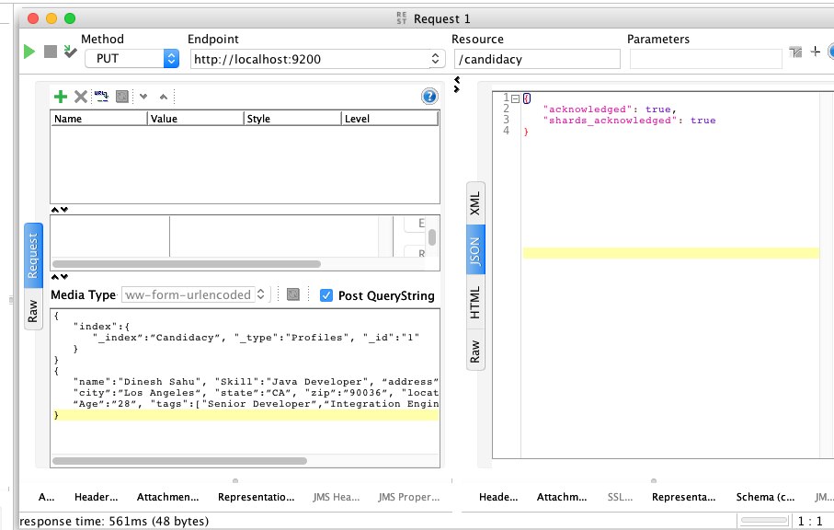

Elastic search data upload, exposing through a REST endpoint

Endpoint - <http://localhost:9200/candidacy>

Request :

{

"index":{

"_index”:”Candidacy”, "_type":"Profiles", "_id":"1"

}

}

{

"name":"Dinesh Sahu", "Skill":"Java Developer", “address”:”6286 Colgate Ave”,

"city”:”Los Angeles“, "state”:”CA”, "zip”:”90036”, "location":[31.8955385,76.8380405],

“Age”:”28”, "tags":["Senior Developer”,“Integration Engineer”,”Project Manger”],

}

Response:

{

"acknowledged": true,

"shards_acknowledged": true

}